
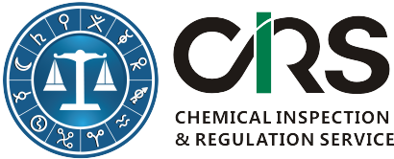
Order Form for CIRS’s Products & Services
First Name(*):
Last Name(*):
Email (*):
Company or Organization(*):
Company Address(*):
Company VAT No. | Required for EU companies
Affiliated companies:
Which product would you like to order? | Option 1: 2,000 RMB or 320 USD  Comparing the new draft Chinese phrases for hazard and precautionary statements with old version (English spreadsheet with h & p codes).  Option 2: 3,000 RMB or 480 USD  Comparing new Chinese phrases for hazard and precautionary statements with old version (English spreadsheet with h & p codes); obtaining further updated version of Chinese H & P phrases free of charge.
Which regulations are you interested? (Consultants will be assigned according to your choice. Optional) | Industrial Chemical Regulations(New Substance Notification, Hazardous Chemicals Management, Restricted Chemicals) in China;  GHS and TDG(SDS/Labelling/Packaging);  Cosmetic Regulations in China;  Pesticide Regulations in China;  Biocides Regulations in China;  Food Additive/Food Packaging/Food Contact Regulations in China;
Any questions?

Please complete this form and send it to service@cirs-reach.com. We will send above documents to you immediately after receiving this completed order form and send you an invoice after.

CIRS Bank Information
Beneficiary Name: CIRS Ltd
Bank Name: Bank of Ireland
Bank Address: Wilton, Cork, Republic of Ireland
Sort Code: 902805
Account #: 90404884
BIC/Swift: BOFIIE2D
IBAN: IE15 BOFI 9028 0590 4048 84

