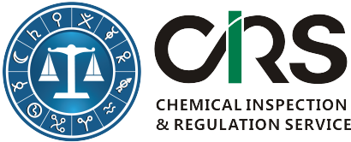
CHEMICAL INSPECTION & REGULATION SERVICE LTD.
SINGLETON HOUSE, LAURENCE STREET
DROGHEDA, CO. LOUTH, IRELAND
TEL: + 353 41 9806916 | FAX: +353 41 9806999
WEBSITE: http://www.cirs-reach.com/

Application Form for Checking Confidential Section of IECSC
Applicant Information
First Name(*):
Last Name(*):
Email (*):
Company or Organization(*):
Telephone:
Questions or comments:
Substance Information( in case of mixture, please fill in each ingredient separately)
Index | Substance Name |  | CAS Number | Molecular Structure
1
2
3
4
5
6
7
8
Terms & Conditions:
For substances that are not included in the public portion of IECSC, CIRS offers free enquiry service to confirm with CRC whether the substance has been listed in the confidential section of IECSC. This offer is limited to one substance per company only. If there is more than 1 substance to search, we charge 100 Euros per additional substance. The fee includes 100 USD paid to the Chemical Registration Centre(CRC) of the Chinese Ministry of Environmental Protection.

Please finish this form and send it to eric.xiong@cirs-reach.com. We will leave our comments and advice below:

