
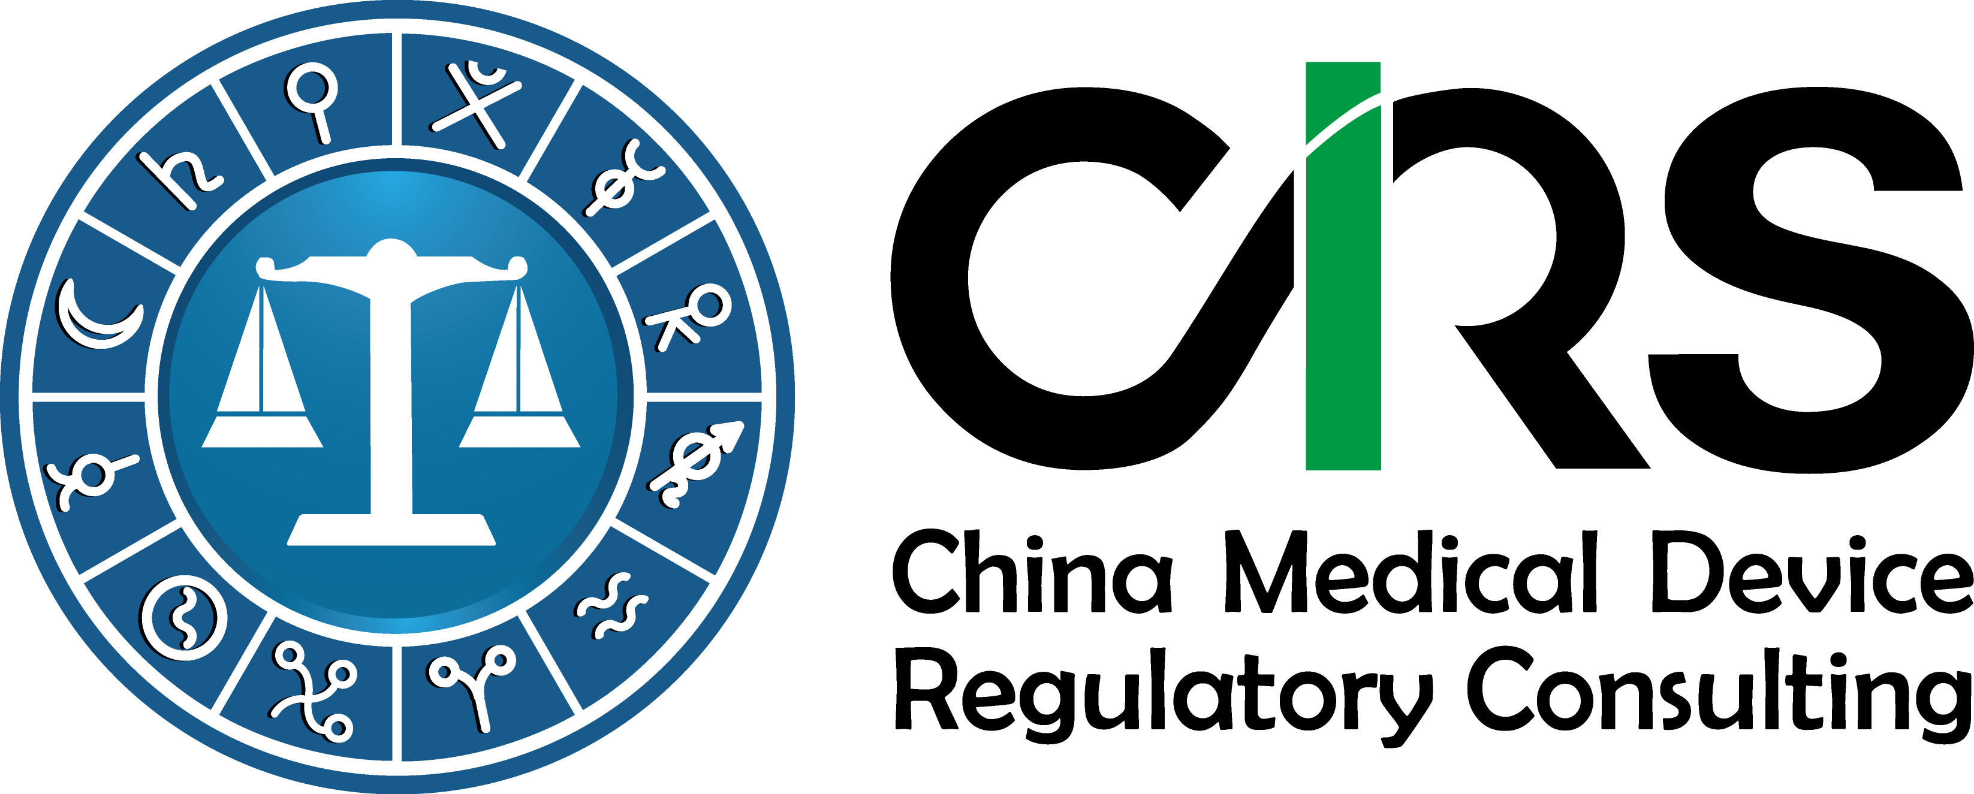
Service Order Form for Medical Device Classification in China

First Name(*):
Last Name(*):
Email (*):
Company or Organization(*):
Company Address(*):
Company VAT No.
Affiliated companies:
Which option would you like to choose? | Option 1: 500USD (430EUR)  Option 2: 1,000 USD (860EUR)
Work Scope  Please complete this form and send it to Edwin.wen@cirs-group.com. We will contact you and start the work immediately after receiving this completed order form and send you an invoice after. | Option 1  - Application of medical device classification determination from local authorities.  - Negotiation with the local authorities for product classification determination.  - Obtain the classification determination letter from CFDA and deliver it to the client.  Option 2  Besides above mentioned services, the following service included:  - Prepare the registration proposal according to the classification determination letter.  - Confirm your regulatory obligations under the CFDA regulations.  General Services:  - Pre-market Investigation & Analysis.  - Medical Device Registration & Approval.  - Clinical Trial Consulting.  - Manufacturing and Distributing License Approval.  - Quality Assurance & Compliance.  - Ad hoc consultancy.
Benefits & Services Delivered | - Removing language and cultural barrier;  - Avoiding hiring full-time staff and lowering your compliance costs;  - Product regulatory compliance check & advice;  - Having local regulatory affairs staff clarifying your questions, analyzing the impact of any medical device regulations on your business and communicating with authorities in China;
The person signing this Agreement represents that he or she intends to and has the authority to bind his or her respective party to this Order Form:

Signature: Print Name: Date:
Terms & Conditions
- Purpose. Hangzhou CIRS Co., Ltd (CIRS) is an independent firm providing professional medical device regulatory consulting services to a variety of industries in China. “Affiliate” means any corporation, limited liability company, partnership or similar legal entity that either party is controlled by, controls or is under common control (provided “control” means the ownership of more than 50% of the voting interests in such legal entity). Before CIRS provides any services, Client or its affiliate must sign and deliver this agreement to CIRS.
- Term. This Agreement will commence on the Effective Date and expire after 1 year. After such period, this Agreement will automatically renew for successive one-year periods, unless either party provides the other party a written termination notice at least 30 days prior to the expiration date of the then-current period. Neither this Agreement nor any Addendum may be terminated early for the convenience of either party. Notwithstanding the foregoing, this Agreement will continue in full force and effect with respect to any specific Addendum so long as such Addendum remains in effect by its terms.
- Invoices. Unless otherwise specifically provided in any Addendum, CIRS will deliver an invoice to Client annually in advance identifying the services and itemizing the fees. Client will pay any invoice within 30 days of the invoice date; and if Client does not pay any invoice within such period, Client will pay CIRS a late charge on the amount due at the rate per month of 1% or the highest rate allowed by applicable law (whichever is lower). All fees payable in connection with this Agreement exclude any applicable taxes and assessments (including all interest, penalties and additions with respect thereto), and all such applicable taxes and assessments are to be borne and paid by Client; provided, however, that CIRS is responsible for payment of taxes based on CIRS’s income, payroll or gross receipts.
- CIRS Warranties. CIRS represents and warrants that CIRS or its staff has sufficient knowledge and technical background to provide Client and its Affiliates with the services & information in this agreement. CIRS further represents and warrants that any services or information provided by CIRS will not constitute an infringement upon the intellectual property, publicity, privacy or any other right of any third party.
- Compliance with Laws. Each party will comply with all laws and regulations applicable to its performance of this Agreement.
- Termination. If a party fails to observe or perform any obligation under this Agreement, the non-defaulting party may give written notice to the defaulting party specifying such failure. If such failure is not corrected, or a mutually agreed plan to correct such failure is not established, within 60 days after the date of such notice, the non-defaulting party may terminate this Agreement and each (or only the applicable) Addendum upon written notice to the defaulting party. If the defaulting party is CIRS, CIRS shall refund fee for the services that are not delivered yet within 30 days since an invoice is received from the non-defaulting party.
- Counterparts. This Agreement may be signed in one or more counterparts, each of which is deemed an original, but all of which taken together constitute one and the same instrument. A facsimile or electronic transmission of a signed version of this Agreement or any Addendum is legal and binding on all parties.

